**Check in:** How is school going for you? Ask each student to share if they want.

**Homework help**: Ask the students to share their screen and show you what they are working on. If you are having trouble getting the students to share below are some questions you can ask to stimulate the conversation on what they are learning and what they may need help on.

Ask questions like:

* What homework did you have this week?
* Can you show me you English/math/ history…?
* Can you tell me about what you did in history/English/ math/ science this week?
  + Can you explain it to me?

***NOTE****: I always make 2-3 extra rooms. If you need to do some one on one homework help send me a text and I can move you or hit call host. You can also go back to the main room with the student though there may be other people in the main room.*

**Brain break game**: 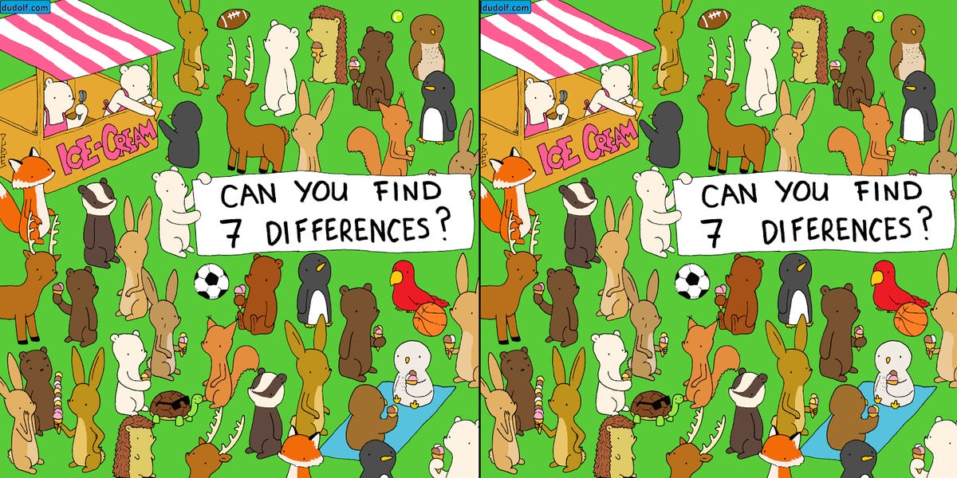

**Remainders in division, review**: <https://youtu.be/VJyk81HmcZQ> and <https://youtu.be/P1qyjdh_sIw>

* Practice: <https://www.khanacademy.org/math/cc-fourth-grade-math/division/4th-remainders/e/estimate-to-divide-by-1-digit-numbers?modal=1>
* <https://www.khanacademy.org/math/cc-fourth-grade-math/division/4th-remainders/e/understanding-remainders?modal=1>

**Mini Welcome Club lesson**: leave 10 minutes to do this.

Coach: ‘ What does integrity mean?’ Coaches call on a student or multiple students. Coach: ‘Can you give me an example of when you did the right think this week?’ Coaches encourage students to speak up or write in the chat. As student share ask them

* How did you feel when...(when they did the right thing)?
* Why did you feel … (happy, sad, angry..)?
* Would you do it the same way again? What would you do differently?

Coach: ‘thank you for your stories Now, I am going to share a time I did not show integrity. I want you to think about what I should have done, okay?’ Check with student and ask them what they are supposed to think about. (What the coach should have done)

Coach: When I was 11 years old, I liked to go to the park and play. One day my big sister was at the park with me. My friends and I were eating candy and one of my friends threw the paper wrappers on the ground. My older sister told me to remember to pick up the paper wrappers and that she was going to go home. I told her okay, see you later. I then went and played on the swings with my friends. I told my friend who made the mess to clean up the candy wrappers. He didn’t pick up the wrappers. I didn’t pick up the paper wrappers either because it was my friend's mess.

Was it okay that I didn’t pick up the paper? Why?

What would you have done?

How could I show integrity in that situation?

**Games**: Kahoot! Science egg questions

<https://kahoot.it/challenge/09370459?challenge-id=e21d906a-1678-4c6e-a9ee-5f26c1dc0f29_1617121540415>

* Game PIN: **09370459**
* Feel free to talk about the questions and give hints. Timer is turned off for this game.

**Wrap up** finish working on what you are working on or transition to the game.